Consultation Report: A Systematic Mapping study of Techniques Applied to Bug Traceability

1. Data Extraction for Research Questions
   1. RQ1: What are the times/venues of the studies?

|  |  |  |  |  |  |
| --- | --- | --- | --- | --- | --- |
| **Index** | **Title** | **Author** | **Year** | **Venue** | **Publication** |
| S1 | FRLink: Improving the recovery of missing  issue-commit links by  revisiting file relevance | Yan Sun  Qing Wang  Ye Yang | 2017 | Information and Software Technology  （IST） | Journal |
| S2 | Automatically Matching Bug Reports With Related  App Reviews | Mario Haering  Christoph Stanik  Walid Maalej | 2021 | International Conference on Software Engineering  （ICSE） | Conference |
| S3 | Analyzing Requirements and Traceability Information to  Improve Bug Localization | Michael Rath  David Lo  Patrick Mäder | 2018 | Mining Software Repositories（MSR） | Conference |
| S4 | Automated Recovery of Issue-Commit Links  Leveraging Both Textual and Non-textual Data | Pooya Rostami Mazrae  Maliheh Izadi  Abbas Heydarnoori | 2021 | International Conference on Software Maintenance and Evolution  (ICSME) | Conference |
| S5 | BTLink : automatic link recovery between issues and commits based on pre-trained BERT model | Jinpeng Lan  Lina Gong  Jingxuan Zhang  Haoxiang Zhang | 2023 | Empirical Software Engineering | Journal |
| S6 | Do Information Retrieval Algorithms for Automated  Traceability Perform Effectively on Issue Tracking  System Data? | Thorsten Merten  Daniel Krämer  Bastian Mager  Paul Schell  Simone Bürsner  Barbara Paech | 2016 | Requirements Engineering: Foundation for Software Quality  (REFSQ) | Conference |
| S7 | Enhancing Model-based Fault Traceability by Using Similarity between Bug and Commit  Information | Dongju Jung  Kyeongsic Min  Jung-Won Lee  Byungjeong Lee | 2019 | JOURNAL OF INTERNET COMPUTING AND SERVICES (JICS) | Journal |
| S8 | Enhancing Traceability Link Recovery with Unlabeled Data | Jianfei Zhu  Guanping Xiao  Zheng Zheng  Yulei Sui | 2022 | IEEE International Symposium on Software Reliability  Engineering  （ISSRE） | conference |
| S9 | Eye movements in software traceability link recovery | Bonita Sharif  John Meinken  Timothy Shaffer  Huzefa Kagdi | 2017 | Empirical Software Engineering  (ESE) | Journal |
| S10 | SpojitR: Intelligently Link Development Artifacts | Michael Rath  Mihaela Todorova Tomova  [Patrick Mäder](https://ieeexplore.ieee.org/author/37089272433) | 2020 | IEEE International Conference on Software Analysis,  Evolution,  and Reengineering  （SANER） | Conference |
| S11 | Identifying Supplementary Bug-fix Commits | Tao Ji  Jinkun Pan  Liqian Chen  Xiaoguang Mao | 2018 | International Computer Software and Applications Conference  （COMPSAC） | Conference |
| S12 | Influence of Structured Information in Bug Report  Descriptions on IR-based Bug Localization | Michael Rath  Patrick Mäder | 2018 | Euromicro Conference on Software Engineering and Advanced Applications  （SEAA） | Conference |
| S13 | Issue Link Label Recovery and Prediction for Open Source Software | Alexander Nicholson  Jin L.C. Guo | 2021 | IEEE International Requirements Engineering Conference Workshops (REW) | Workshops |
| S14 | Locating Bug IDs and Development Logs in Open  Source Software (OSS) projects:  An Experience Report | Bilyaminu Auwal Romo  Andrea Capiluppi  Ajaz Ali | 2018 | International Conference on Innovation and Intelligence for Informatics, Computing, and Technologies (3ICT) | Conference |
| S15 | On the effectiveness of automated tracing from model changes to project issues | Wouter van Oosten  Randell Rasiman  Fabiano Dalpiaz  Toine Hurkmans | 2023 | Information and Software Technology  (IST) | Journal |
| S16 | RCLinker: Automated Linking of Issue Reports and Commits Leveraging Rich Contextual Information | Tien-Duy B. Le  Mario Linares Vasquez  David Lo  Denys Poshyvanyk | 2015 | IEEE International Conference on Program  Comprehension  （ICPC） | Conference |
| S17 | EALink: An Efficient and Accurate Pre-trained  Framework for Issue-Commit Link Recovery | Chenyuan Zhang  Yanlin Wang  Zhao Wei  Yong Xu  Juhong Wang  Hui Li  Rongrong Ji | 2023 | International Conference on Automated Software Engineering  （ASE） | Conference |
| S18 | Traceability in the Wild:  Automatically Augmenting Incomplete Trace Links | Michael Rath  Jacob Rendall  Jin L.C. Guo  Jane Cleland-Huang  Patrick Mäder | 2018 | International Conference on Software Engineering  （ICSE） | Conference |
| S19 | Traceability recovery between bug reports and test cases‑a  Mozilla Firefox case study | Guilherme Gadelha  Franklin Ramalho  Tiago Massoni | 2021 | Automated Software Engineering  （ASE） | Journal |
| S20 | AmaLgam+: Composing rich information sources for accurate bug localization | Shaowei Wang  David Lo | 2016 | Journal of Software: Evolution and Process | Journal |
| S21 | Bug Localization Based on Code Change Histories  and Bug Reports | Klaus Changsun Youm  June Ahn  Jeongho Kim  Eunseok Lee | 2015 | Asia-Pacific Software Engineering Conference  （APSEC） | Conference |
| S22 | Discovering Loners and Phantoms in Commit and Issue Data | Gerald Schermann  Martin Brandtner  Sebastiano Panichella  Philipp Leitner  Harald Gall | 2015 | IEEE International Conference on Program  Comprehension  （ICPC） | Conference |
| S23 | Improving Missing Issue-Commit Link Recovery  using Positive and Unlabeled Data | Yan Sun  Celia Chen  Qing Wang  Barry Boehm | 2017 | International Conference on Automated Software Engineering  （ASE） | Conference |
| S24 | RAT: A Refactoring-Aware Traceability Model for  Bug Localization | Feifei Niu  Wesley K. G.Assunção  LiGuo Huang  Christoph Mayr-Dorn  Jidong Ge  Bin Luo  Alexander Egyed | 2023 | International Conference on Software Engineering  （ICSE） | conference |

* 1. Extracted data for RQ2 and RQ3: What is the definition of BT?

What types of bug trace links are recovered from primary studies?

|  |  |  |  |
| --- | --- | --- | --- |
| **Index** | **Source Artifact** | **Target Artifact** | **Datasets** |
| S1 | Bug Report | Commit | CLI  Collections  CSV  IO  Lang  Math |
| S2 | Bug Report | Problem Report | Firefox Browser  VLC Media Player  VLC Media Player  Nextcloud |
| S3 | Bug Report | Source Code | Axis2  Derby  Drools  Hadoop  HornetQ  Infinispan  Izpack  Keycloak  Log4J2  Pig  Railo  Seam2  Teiid  Weld  Wildfly |
| S4 | Bug Report | Commit | Beam  Flink  Freemarker  Airflow  Arrow  Netbeans  Ignite  Isis  Groovy  Cassandra  Ambari  Calcite |
| S5 | Bug Report | Commit | Isis  Beam  Tika  Tez  Avro  Nutch  OODT  Ivy  Giraph  Buildr  Keras  Log4net |
| S6 | Bug Report | Feature  Bug Report | c:geo  Lighttpd  Radiant  Redmine |
| S7 | Bug Report | Commit | Zxing |
| S8 | Bug Report | Commit | For train  Albergate  CCHIT  CMI  eANCI  EasyClinic  EBT  eTOUR  GANNT  HIPAA  Ice Breaker  Infused Pump  iTrust  Kiosk  SMOS  WARC  For evaluation  Flask  Pgcli  Keras |
| S9 | Bug Report | Source Code | JabRef  (a graphical application for managing bibliographic databases) |
| S10 | Bug Report | Commit | CRUNCH  FALCON  AVRO  PIG  KAFKA |
| S11 | Bug Report | Commit | WordPress-Android  Atom  Moby  OpenCV  Kubernetes  Swift |
| S12 | Bug Report | Source Code | Derby  Drools  Groovy  Infinispan  Maven  Pig  Seam2 |
| S13 | Bug Report | Bug Report | Hive  Ambari  Flex |
| S14 | Bug Report | Commit | Brackets  Leaflet  Reddit  CocoaPods  Puma  AutoMapper  MonoDevelop  CodeHub  Manos  puppet |
| S15 | Commit | Bug Report | Company  Control  Data  Learn  Portfolio  Service  Store |
| S16 | Bug Report | Commit | CLI  Collections  CSV  IO  Lang  Math |
| S17 | Bug Report | Commit | Ambari  Calcite  Groovy  Ignite  Isis  Netbeans |
| S18 | Bug Report | Commit | Derby  Drools  Groovy  Infinispan  Maven  Pig |
| S19 | Bug Report | Test Case | Mozilla Firefox |
| S20 | Bug Report | Source Code | AspectJ  Eclipse  SWT  ZXing |
| S21 | Bug Report | Source Code | AspectJ  SWT  ZXing |
| S22 | Bug Report | Commit | ActiveMQ  Ambari  Camel  CXF  Felix  Hadoop  HBase  Hive  Jackrabbit Oak  Karaf  PDFBox  Sling  Spark  Stanbol  Tika |
| S23 | Bug Report | Commit | Avro  Buildr  Chukwa  Falcon  Giraph  Ivy  Knox  Log4net  Nutch  OODT  Tez  Tika |
| S24 | Bug Report | Source Code | Derby  Drools  Hornetq  Izpack  Keycloak  Log4j2  Railo  Seam2  Teiid  Weld  Wildfly |

|  |  |  |  |  |
| --- | --- | --- | --- | --- |
| Source Artifact | Target Artifacts | Datasets | Reference | Datasets (Freq. > 2) |
| Bug Report | Commit | CLI, Collections, CSV, IO, Lang, Math, Beam, Flink, Freemarker, Airflow, Netbeans, Ignite, Isis, Groovy, Cassandra , Ambari , Calcite, Tika, Tez, Avro, Nutch, OODT, Ivy, Giraph, Buildr, Keras, Log4net, Zxing, Flask, Pgcli, Keras, Crunch, Falcon, Pig, Kafka, WordPress-Android, Atom, Moby, OpenCV, Kubernetes, Swift, Brackets, Leaflet, Reddit, CocoaPods, Puma, AutoMapper, MonoDevelop, CodeHub, Manos, puppet, Derby, Drools, Infinispan, Maven, ActiveMQ, Camel, CXF, Felix, Hadoop, HBase, Hive, Jackrabbit Oak, Karaf, PDFBox, Sling, Spark, Stanbol, Chukwa, Knox, Company, Control, Data, Learn, Portfolio, Service, Store | S1, S4, S5, S7, S8, S10, S11, S14, S15, S16, S17, S18, S22, S23 | Isis, Groovy,  Ambari, Tika,  Avro, Zxing,  Pig, Derby,  Drools,  Infinispan,  Seam2 |
| Source Code | Axis2, Derby, Drools, Hadoop, HornetQ, Infinispan, Izpack, Keycloak, Log4J2, Pig, Railo, Seam2, Teiid, Weld, Wildfly, JabRef, Groovy, Maven, Seam2, AspectJ, Eclipse, SWT, ZXing | S3, S9, S12, S20, S21, S24 |
| Problem Report | Firefox Browser,VLC Media Player,VLC Media Player,Nextcloud | S2 |
| Bug Report | c:geo,Lighttpd,Radiant,Redmine,Hive,Ambari,Flex | S6, S13 |
| Feature | c:geo,Lighttpd,Radiant,Redmine | S6 |
| Test Case | Mozilla Firefox | S19 |

* 1. RQ4：Which techniques are used in the process of BTR?

|  |  |  |  |
| --- | --- | --- | --- |
| Index | Title | Model | Categories of techniques used |
| S1 | FRLink: Improving the recovery of missing issue-commit links by  revisiting file relevance | FRLink | IR |
| S2 | Automatically Matching Bug Reports With Related  App Reviews | DeepMatcher | DL |
| S3 | Analyzing Requirements and Traceability Information to Improve Bug Localization | TraceScore | IR+ML+DL+Other |
| S4 | Automated Recovery of Issue-Commit Links Leveraging Both Textual and Non-textual Data | Hybrid-Linker | ML+IR+Other |
| S5 | BTLink : automatic link recovery between issues and commitsbased on pre-trained BERT model | BTLink | DL |
| S6 | Do Information Retrieval Algorithms for Automated  Traceability Perform Effectively on Issue Tracking System Data? | OpenTrace | IR |
| S7 | Enhancing Model-based Fault Traceability by Using Similarity between Bug and Commit Information | Fault Traceability Enhancement Technique | IR +Heuristic+Other |
| S8 | Enhancing Traceability Link Recovery with  Unlabeled Data | TRACEFUN | IR+DL |
| S9 | Eye movements in software traceability link recovery | iTrace | eye-tracking based |
| S10 | SpojitR: Intelligently Link Development Artifacts | SpojitR | ML+IR |
| S11 | Identifying Supplementary Bug-fix Commits | SupBCFinder | ML + Heuristic |
| S12 | Influence of Structured Information in Bug Report  Descriptions on IR-based Bug Localization | - | IR + Heuristic |
| S13 | Issue Link Label Recovery and Prediction for Open  Source Software | - | IR+ ML+DL+Other |
| S14 | Locating Bug IDs and Development Logs in Open Source Software (OSS) projects:An Experience Report | - | SZZ |
| S15 | On the effectiveness of automated tracing from model changes to project  issues | LCDTrace | ML+IR |
| S16 | RCLinker: Automated Linking of Issue Reports and Commits Leveraging Rich Contextual Information | RCLinker | ML+Other |
| S17 | EALink: An Efficient and Accurate Pre-trained  Framework for Issue-Commit Link Recovery | EALink | DL |
| S18 | Traceability in the Wild:  Automatically Augmenting Incomplete Trace Links | - | IR+ML+Other |
| S19 | Traceability recovery between bug reports and test cases‑a  Mozilla Firefox case study | - | IR+DL |
| S20 | AmaLgam+:Composing rich information sources for accurate bug localization | AmaLgam+ | IR+Other |
| S21 | Improved bug localization based on code change histories and bug  reports | BLIA | IR |
| S22 | Discovering Loners and Phantoms in Commit and Issue Data | PaLiMod | heuristics |
| S23 | Improving Missing Issue-Commit Link Recovery  using Positive and Unlabeled Data | PULink | ML |
| S24 | RAT: A Refactoring-Aware Traceability Model for Bug Localization | RAT | IR+ML+Other |

|  |  |  |  |  |  |  |
| --- | --- | --- | --- | --- | --- | --- |
| Index | ML | Stage | DL | Stage | IR | Stage |
| S1 |  |  |  |  | 1) VSM  2) TF-IDF | 1）Link generation  2）Link preparation |
| S2 |  |  | DistilBERT | Link preparation |  |  |
| S3 | decision tree | Link generation |  |  | 1) VSM  2) TF-IDF | Link generation |
| S4 | 1) Decision Tree,  2) Gradient Boosting,  3) Logistic Regression，  4) Stochastic Gradient Descent,  5) Naïve Bayes,  6) Generalized Linear,  7) Random Forest,  8) XGBoost model | Link generation | 1) Word2Vec  2) Doc2Vec | Link preparation | TF-IDF | Link preparation |
| S5 |  |  | 1) RoBERTa  2) CodeBERT | Link preparation |  |  |
| S6 |  |  |  |  | 1) VSM,  2) LSI, BM25,  3) BM25+,  4) BM25L | Link generation |
| S7 |  |  |  |  | 1) VSM  2) TF-IDF | 1) Link generation  2) Link preparation |
| S8 |  |  | 1) Glove  2) LSTM | 1) Link preparation 2) Link generation | 1) VSM  2) TF-IDF | 1) Link generation  2) Link preparation |
| S9 |  |  |  |  |  |  |
| S10 | random forest | Link generation |  |  | 1) VSM-nGram  2) TF-IDF | Link generation  Link preparation |
| S11 | SVM | Link preparation |  |  |  |  |
| S12 |  |  |  |  | 1) BLUiR  2) AmaLgam | Link  generation |
| S13 | 1) Logistic Reg ression  2) Random Forest  3) fastText | 1) 2) Link generation  3) Link preparation | Neural Network  （Link classification） | Link generation | TF-IDF | Link preparation |
| S14 |  |  |  |  |  |  |
| S15 | 1) XGBoost  2) LightGBM  3) Random Forests | Link generation |  |  | 1) VSM  2) TF-IDF | 1) Link generation  2) Link preparation |
| S16 | Random forest | Link generation |  |  |  |  |
| S17 |  |  | 1) RoBERTa、  2) CodeBERT  3) Contrastive learning | Link preparation |  |  |
| S18 | 1) Naive Bayes  2) Decision Tree  3) Random Forest | Link generation |  |  | VSM-nGram | Link generation |
| S19 |  |  | Glove | preprocessing stage | 1) LSI  2) LDA  3) BM25 | Link generation |
| S20 |  |  |  |  | 1) BugLocator  2) BLUiR  3) TF-IDF | 1) 2) Link generation  3) preparation |
| S21 |  |  |  | tr | rVSM | Link generation |
| S22 |  |  |  |  |  |  |
| S23 | Random Forest | Link generation |  |  |  |  |
| S24 | SVM | Link generation |  |  | 1) VSM  2) TF-IDF | 1) Link generation  2) Link preparation |

|  |  |  |  |  |  |  |
| --- | --- | --- | --- | --- | --- | --- |
| Index | Heuristic | Stage | Eye-tracking | Stage | Other | Stage |
| S1 |  |  |  |  |  |  |
| S2 |  |  |  |  |  |  |
| S3 |  |  |  |  | RUS feature  （data balance） | Link preparation |
| S4 |  |  |  |  | 1) one-hot transformation  2) RUS | Link preparation |
| S5 |  |  |  |  |  |  |
| S6 |  |  |  |  |  |  |
| S7 | keyword extraction heuristic | Link preparation |  |  | Behavior Model | Link refinement |
| S8 |  |  |  |  |  |  |
| S9 |  |  | Itrace | Link generation |  | Link generation |
| S10 |  |  |  |  |  |  |
| S11 | identify commit Heuristics | Link preparation |  |  |  |  |
| S12 | text tagging heuristic | Link preparation |  |  |  |  |
| S13 |  |  |  |  | SMOTE |  |
| S14 |  |  |  |  | SZZ | Link preparation |
| S15 |  |  |  |  | 1) RUS、  2) SMOTE | Link preparation |
| S16 |  |  |  |  | 1) Near-Miss  2)ChangeScribe | Link preparation |
| S17 |  |  |  |  |  |  |
| S18 |  |  |  |  | sub-sampling feature | Link preparatio |
| S19 |  |  |  |  |  |  |
| S20 |  |  |  |  | Genetic Algorithm | Link generation |
| S21 |  |  |  |  |  |  |
| S22 | (1) Loner heuristic  (2) Phantom heuristic. | Link generation |  |  |  |  |
| S23 |  |  |  |  |  |  |
| S24 |  |  |  |  | 1) SimiScore  2) TraceScore | Link generation |

* 1. RQ5：Which metrics are used to evaluate the performance of BTR techniques?

|  |  |  |
| --- | --- | --- |
| S1 | FRLink: Improving the recovery of missing issue-commit links by  revisiting file relevance | Precision  Recall  F-measure  MCC |
| S2 | Automatically Matching Bug Reports With Related  App Reviews | MAP  Hit Ratio |
| S3 | Analyzing Requirements and Traceability Information to  Improve Bug Localization | MAP  MRR  Top@1、5、10 |
| S4 | Automated Recovery of Issue-Commit Links  Leveraging Both Textual and Non-textual Data | Precision  Recall  F1 |
| S5 | BTLink : automatic link recovery between issues and commits  based on pre-trained BERT model | F  MCC  ACC  PF  AUC  Precision  Recall |
| S6 | Do Information Retrieval Algorithms for Automated  Traceability Perform Effectively on Issue Tracking  System Data? | Precision  Recall  F1  F2 |
| S7 | Enhancing Model-based Fault Traceability by  Using Similarity between Bug and Commit  Information | Accuracy |
| S8 | Enhancing Traceability Link Recovery with  Unlabeled Data | MAP  F1  F2 |
| S9 | Eye movements in software traceability link recovery | Precision  Recall |
| S10 | SpojitR: Intelligently Link Development Artifacts | Precision  Recall  Accuracy |
| S11 | Identifying Supplementary Bug-fix Commits | Precision  Recall  F-measure |
| S12 | Influence of Structured Information in Bug Report  Descriptions on IR-based Bug Localization | Top@k：Top-1、Top-2、Top-3  MAP  MRR |
| S13 | Issue Link Label Recovery and Prediction for Open  Source Software | F1 |
| S14 | Locating Bug IDs and Development Logs in Open  Source Software (OSS) projects:  An Experience Report | Precision  Recall  F-measure |
| S15 | On the effectiveness of automated tracing from model changes to project  issues | F2  F0.5  Precision  Recall |
| S16 | RCLinker: Automated Linking of Issue Reports and  Commits Leveraging Rich Contextual Information | Precision  Recall  F-measure |
| S17 | EALink: An Efficient and Accurate Pre-trained  Framework for Issue-Commit Link Recovery | Precision@k  NDGG@k  MRR  Hit@k |
| S18 | Traceability in the Wild:  Automatically Augmenting Incomplete Trace Links | Precision  Recall  F2  F0.5 |
| S19 | Traceability recovery between bug reports and test cases‑a  Mozilla Firefox case study | Precision  Recall  F2  REI |
| S20 | AmaLgam+: Composing rich information sources for accurate bug localization | MAP  MRR  Hit@1  Hit@5  Hit@10 |
| S21 | Improved bug localization based on code change histories and bug  reports | Top 1  Top 5  MAP  MRR |
| S22 | Discovering Loners and Phantoms in Commit and Issue Data | Precision  Recall  F-measure |
| S23 | Improving Missing Issue-Commit Link Recovery  using Positive and Unlabeled Data | Precision  Recall  F-measure |
| S24 | RAT: A Refactoring-Aware Traceability Model for  Bug Localization | Top@1、5、10  MAP  MRR |

|  |  |  |  |  |  |  |  |  |  |  |  |  |  |  |  |  |  |
| --- | --- | --- | --- | --- | --- | --- | --- | --- | --- | --- | --- | --- | --- | --- | --- | --- | --- |
| Reference | **Primary Metrics** | | | | | | | | **Secondary Metrics** | | | | | | | | Total |
| F-measures | | | Recall | Precision | Accuracy | Top@n | Hit@n | MCC | MAP | MRR | ACC | PF | AUC | NDGG@K | REI |
| F1 | F2 | F 0.5 |
| S1 | 🗸 |  |  | 🗸 | 🗸 |  |  |  | 🗸 |  |  |  |  |  |  |  | 4 |
| S2 |  |  |  |  |  |  |  | 🗸 |  | 🗸 |  |  |  |  |  |  | 2 |
| S3 |  |  |  |  |  |  | 🗸 |  |  | 🗸 | 🗸 |  |  |  |  |  | 3 |
| S4 | 🗸 |  |  | 🗸 | 🗸 |  |  |  |  |  |  |  |  |  |  |  | 3 |
| S5 | 🗸 |  |  | 🗸 | 🗸 |  |  |  | 🗸 |  |  | 🗸 | 🗸 | 🗸 |  |  | 7 |
| S6 | 🗸 | 🗸 |  | 🗸 | 🗸 |  |  |  |  |  |  |  |  |  |  |  | 4 |
| S7 |  |  |  |  |  | 🗸 |  |  |  |  |  |  |  |  |  |  | 1 |
| S8 | 🗸 | 🗸 |  |  |  |  |  |  |  | 🗸 |  |  |  |  |  |  | 3 |
| S9 |  |  |  | 🗸 | 🗸 |  |  |  |  |  |  |  |  |  |  |  | 2 |
| S10 |  |  |  | 🗸 | 🗸 | 🗸 |  |  |  |  |  |  |  |  |  |  | 3 |
| S11 | 🗸 |  |  | 🗸 | 🗸 |  |  |  |  |  |  |  |  |  |  |  | 3 |
| S12 |  |  |  |  |  |  | 🗸 |  |  | 🗸 | 🗸 |  |  |  |  |  | 3 |
| S13 | 🗸 |  |  |  |  |  |  |  |  |  |  |  |  |  |  |  | 1 |
| S14 | 🗸 |  |  | 🗸 | 🗸 |  |  |  |  |  |  |  |  |  |  |  | 3 |
| S15 |  | 🗸 | 🗸 | 🗸 | 🗸 |  |  |  |  |  |  |  |  |  |  |  | 4 |
| S16 | 🗸 |  |  | 🗸 | 🗸 |  |  |  |  |  |  |  |  |  |  |  | 3 |
| S17 |  |  |  |  | 🗸 |  |  | 🗸 |  |  | 🗸 |  |  |  | 🗸 |  | 4 |
| S18 |  | 🗸 | 🗸 | 🗸 | 🗸 |  |  |  |  |  |  |  |  |  |  |  | 4 |
| S19 |  | 🗸 |  | 🗸 | 🗸 |  |  |  |  |  |  |  |  |  |  | 🗸 | 4 |
| S20 |  |  |  |  |  |  |  | 🗸 |  | 🗸 | 🗸 |  |  |  |  |  | 3 |
| S21 |  |  |  |  |  |  | 🗸 |  |  | 🗸 | 🗸 |  |  |  |  |  | 3 |
| S22 | 🗸 |  |  | 🗸 | 🗸 |  |  |  |  |  |  |  |  |  |  |  | 3 |
| S23 | 🗸 |  |  | 🗸 | 🗸 |  |  |  |  |  |  |  |  |  |  |  | 3 |
| S24 |  |  |  |  |  |  | 🗸 |  |  | 🗸 | 🗸 |  |  |  |  |  | 3 |

* 1. RQ5：What is the overall quality of primary studies?

|  |  |  |  |  |  |  |  |  |
| --- | --- | --- | --- | --- | --- | --- | --- | --- |
| **Index** | **Q1-Q4** | | | | **Q5-Q8** | | | |
| Research method | Context | Subject | Degree of automation | Context described | Study Design | Validity discussed | Measures  Used |
| S1 | Lab Experience | Academic | Researcher | strong | Strong | Strong | Strong | 0.8 |
| S2 | Case study | Academic | practitioner | strong | Strong | Strong | Medium | 0.6 |
| S3 | Lab Experience | Academic | Researcher | Medium | Medium | Strong | Strong | 0.6 |
| S4 | Lab Experience | Academic | Researcher | strong | Strong | Strong | Strong | 0.6 |
| S5 | Lab Experience | Academic | Researcher | strong | Strong | Strong | Medium | 1.0 |
| S6 | Lab Experience | Academic | Student | strong | Strong | Strong | Medium | 0.8 |
| S7 | Lab Experience | Academic | Student | Medium | Medium | Medium | Weak | 0.2 |
| S8 | Lab Experience | Academic | Researcher | Medium | Strong | Strong | Strong | 0.6 |
| S9 | Case study | Academic | practitioner | strong | Strong | Strong | Strong | 0.6 |
| S10 | Lab Experience | Academic | Researcher | Medium | Medium | Strong | Weak | 0.6 |
| S11 | Lab Experience | Academic | Researcher | Medium | Strong | Strong | Strong | 0.6 |
| S12 | Lab Experience | Academic | Researcher | strong | Medium | Strong | Medium | 0.6 |
| S13 | Case study | Academic | Student | strong | Strong | Strong | Medium | 0.2 |
| S14 | Lab Experience | Academic | Student | Medium | Medium | Medium | Strong | 0.6 |
| S15 | Case study | Industry | Student | strong | Strong | Strong | Strong | 0.8 |
| S16 | Lab Experience | Academic | Student | strong | Strong | Strong | Strong | 0.6 |
| S17 | Case study | Academic | practitioner | strong | Strong | Strong | Medium | 0.8 |
| S18 | Lab Experience | Academic | Researcher | strong | Strong | Strong | Medium | 0.8 |
| S19 | Case study | Academic | Researcher | strong | Strong | Strong | Strong | 0.8 |
| S20 | Lab Experience | Academic | Researcher | strong | Strong | Strong | Strong | 0.6 |
| S21 | Lab Experience | Academic | Student | strong | Strong | Strong | Strong | 0.6 |
| S22 | Lab Experience | Academic | Researcher | Strong | Strong | Strong | Medium | 0.6 |
| S23 | Lab Experience | Academic | Researcher | Strong | Medium | Strong | Weak | 0.6 |
| S24 | Lab Experience | Academic | Student | Strong | Strong | Strong | Strong | 0.6 |

* + 1. RQ5.2：

|  |  |  |  |  |  |  |  |  |  |  |  |  |  |  |
| --- | --- | --- | --- | --- | --- | --- | --- | --- | --- | --- | --- | --- | --- | --- |
| Index | **Method** | | | | | **Data** | | | | **Experiment** | | | | |
| Problem | Objective  /goal | Research method | Research questions | Pseudo code | Training data | Validation data | Test data | Results | Hypothesis and  Prediction | Source code | Hardware  Specificat-ions | Software  dependen-cies | Experi-ment setup |
| S1 | 1 | 1 | 1 | 1 | 1 | 1 | 0 | 1 | 1 | 0 | 1 | 1 | 0 | 1 |
| S2 | 1 | 1 | 1 | 1 | 0 | 1 | 0 | 0 | 1 | 0 | 1 | 0 | 0 | 1 |
| S3 | 1 | 1 | 1 | 1 | 0 | 1 | 0 | 1 | 1 | 1 | 0 | 0 | 1 | 1 |
| S4 | 1 | 1 | 1 | 1 | 0 | 1 | 0 | 1 | 1 | 0 | 1 | 1 | 1 | 1 |
| S5 | 1 | 1 | 1 | 1 | 0 | 1 | 1 | 1 | 1 | 0 | 1 | 1 | 0 | 1 |
| S6 | 1 | 0 | 0 | 1 | 0 | **0** | **0** | **0** | 1 | 0 | 1 | 0 | 1 | 1 |
| S7 | 0 | 0 | 1 | 0 | 1 | 0 | 0 | 0 | 1 | 0 | 0 | 0 | 0 | 1 |
| S8 | 0 | 1 | 1 | 1 | 0 | 1 | 1 | 1 | 1 | 1 | 1 | 1 | 0 | 1 |
| S9 | 1 | 1 | 1 | 1 | 0 | **0** | **0** | **0** | 1 | 1 | 1 | 1 | 1 | 1 |
| S10 | 1 | 1 | 1 | 0 | 0 | 1 | 0 | 1 | 1 | 0 | 1 | 0 | 1 | 1 |
| S11 | 1 | 1 | 1 | 1 | 1 | 1 | 0 | 1 | 1 | 1 | 0 | 0 | 1 | 1 |
| S12 | 0 | 0 | 1 | 0 | 0 | **0** | **0** | **0** | 1 | 0 | 0 | 0 | 0 | 1 |
| S13 | 1 | 1 | 1 | 1 | 0 | 1 | 1 | 1 | 1 | 1 | 0 | 0 | 1 | 1 |
| S14 | 1 | 1 | 1 | 0 | 0 | **0** | **0** | **0** | 1 | 1 | 0 | 0 | 1 | １ |
| S15 | 0 | 1 | 1 | 1 | 0 | 1 | 0 | 1 | 1 | 0 | 1 | 0 | 1 | 1 |
| S16 | 1 | 1 | 1 | 1 | 1 | 1 | 0 | 1 | 1 | 0 | 0 | 1 | 1 | 1 |
| S17 | 1 | 1 | 1 | 1 | 0 | 1 | 1 | 1 | 1 | 0 | 1 | 1 | 1 | 1 |
| S18 | 1 | 1 | 1 | 1 | 0 | 1 | 0 | 1 | 1 | 0 | 0 | 0 | 0 | 1 |
| S19 | 1 | 1 | 1 | 1 | 0 | 1 | 0 | 0 | 1 | 0 | 1 | 1 | 1 | 1 |
| S20 | 1 | 1 | 1 | 1 | 0 | 1 | 0 | 1 | 1 | 1 | 0 | 1 | 1 | 1 |
| S21 | 1 | 1 | 1 | 1 | 0 | **0** | **0** | **0** | 1 | 1 | 1 | 0 | 1 | 1 |
| S22 | 1 | 1 | 1 | 1 | 1 | **0** | **0** | **0** | 1 | 0 | 0 | 0 | 0 | 1 |
| S23 | 1 | 1 | 1 | 0 | 0 | 1 | 1 | 1 | 1 | 0 | 0 | 0 | 0 | 1 |
| S24 | 1 | １ | 1 | 1 | 0 | **0** | **0** | **0** | 1 | 0 | 1 | 0 | 1 | 1 |

**Note：**The values in the data factor are bolded to indicate a weight of 0.

1. Search process record
   1. Digital libraries

|  |  |
| --- | --- |
| Database | Website |
| Google Scholar | https://scholar.google.com/ |
| ScienceDirect | https://www.sciencedirect.com/ |
| EI | https://www.engineeringvillage.com/ |
| IEEE | https://ieeexplore.ieee.org/ |
| Wiley | https://onlinelibrary.wiley.com |
| Springer | https://www.springer.com/ |
| ACM | https://dl.acm.org/ |

* 1. Inclusion/Exclusion criteria

|  |  |
| --- | --- |
| **Inclusion selection criteria** | |
| I1 | The time span of the study is from January 2013 to December 2023, and the study must be published as a journal paper, conference paper or workshop. |
| I2 | The dataset primarily consists of bug report artifacts. |
| I3 | The research topic must be techniques used in the BTR process. |
| I4 | When presented with two papers by the same authors with the same technology and topic, we select the more complete one. |
| **Exclusion selection criteria** | |
| E1 | The study is a review paper or grey literature. |
| E2 | This study is not written in English. |
| E3 | This study is not a complete full-text or is less than 4 pages. |

* 1. Search terms

|  |  |
| --- | --- |
| **PICO** | **Search terms** |
| Population(P) | traceability recovery, traceability maintenance, traceability assessment, trace links, traceability link, bug trace, bug tracing, bug traceability, bug links |
| Intervention(I) | bug, issue, defect |

**Search statements:**

("bug" OR "issue" OR "defect") AND ("traceability recovery" OR "traceability maintenance" OR "traceability assessment" OR "trace links" OR "traceability link" OR "bug trace" OR "bug tracing" OR "bug traceability" OR "bug links")

* 1. Search results

|  |  |  |  |  |  |  |
| --- | --- | --- | --- | --- | --- | --- |
| Database | Number of search | After filtering duplicate studies and  preliminary filtering  (I1, E1-E3) | Filtering by title, abstract, and keyword  (I2-I3) | Filtering by full-text  (I2-I4) | Snowballing | Total |
| Google scholar | 3370 | 121 | 59 | 19 | 5 | 24 |
| ScienceDirect | 539 |
| EI | 90 |
| IEEE | 35 |
| Wiley | 72 |
| Springer | 994 |
| ACM | 256 |

1. Google scholar

Advanced search:

("bug" OR "issue" OR "defect") AND ("traceability recovery" OR "traceability maintenance" OR "traceability assessment" OR "trace links" OR "traceability link" OR "bug trace" OR "bug tracing" OR "bug traceability" OR "bug links")

**Screenshot of search process in** Google scholar:

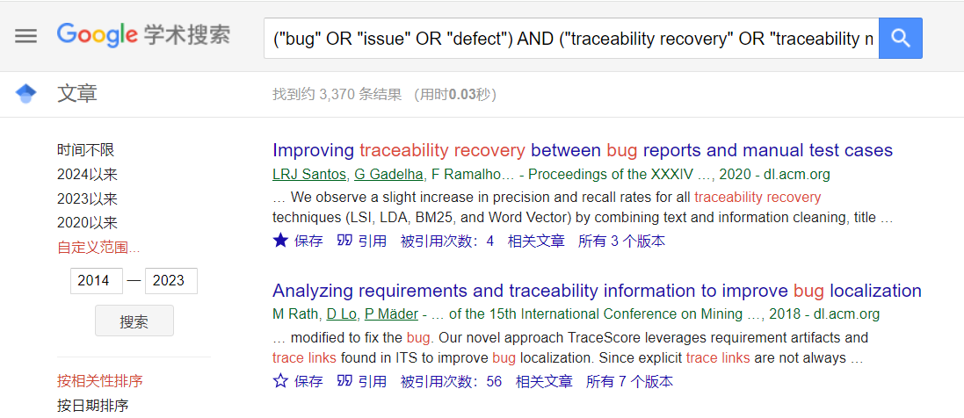

1. ScienceDirect

Advanced search:

("bug" OR "issue" OR "defect") AND ("traceability recovery" OR "traceability maintenance" OR "traceability assessment" OR "trace links" OR "traceability link" OR "bug trace" OR "bug tracing" OR "bug traceability" OR "bug links")

Due to the limitation of Boolean connectors (up to 8 per field), we split the search term into two parts: a) and b).

**Screenshot of search process in** ScienceDirect:

1. ("bug" OR "issue" OR "defect") AND ("traceability recovery" OR "traceability maintenance" OR "traceability assessment" OR "trace links" OR "traceability link")

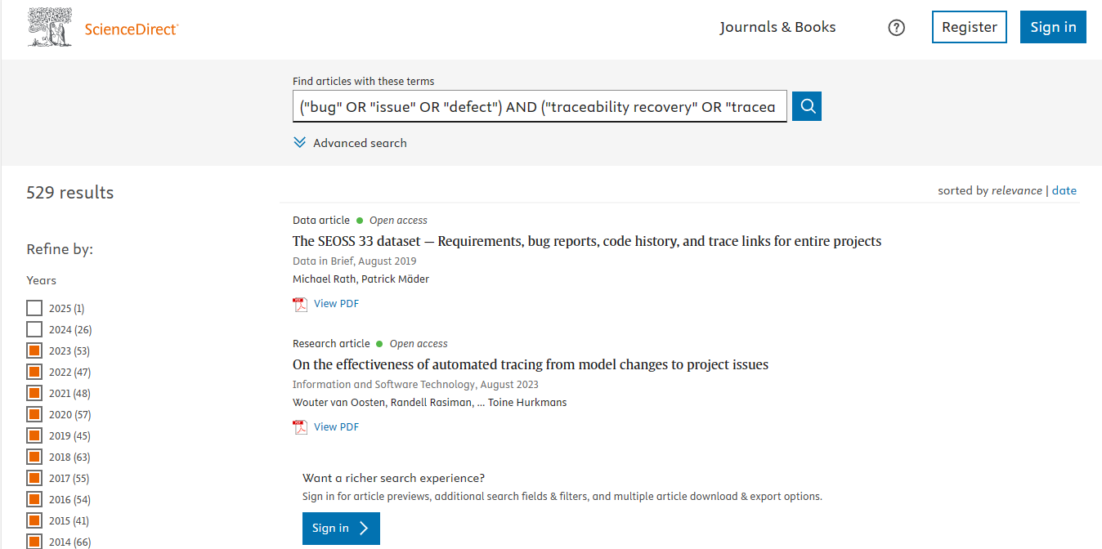

1. ("bug" OR "issue" OR "defect") AND ("bug trace" OR "bug tracing" OR "bug traceability" OR "bug links")

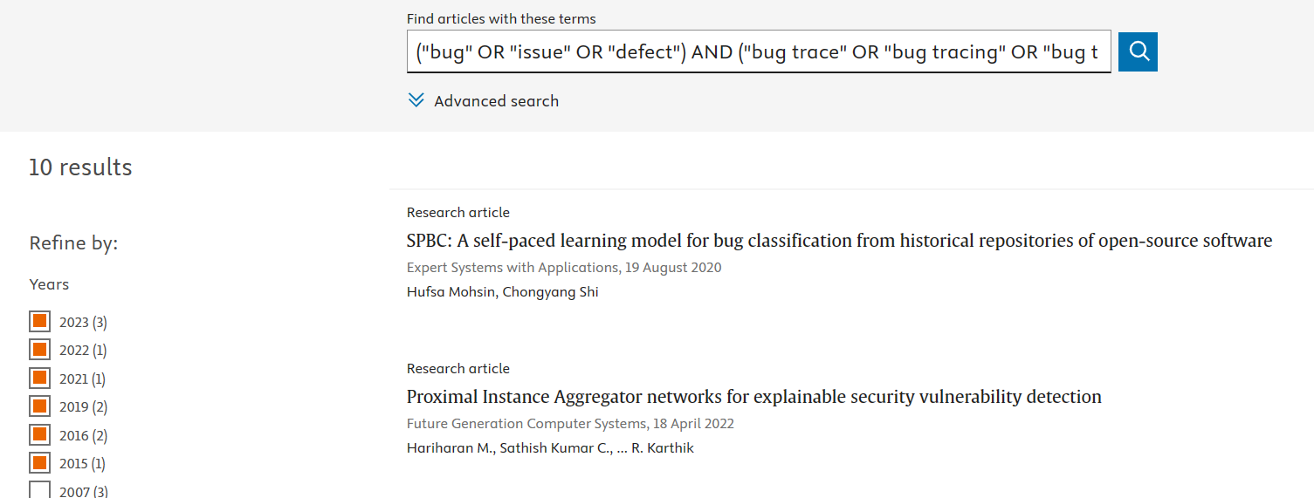

1. EI

Advanced search:

("bug" OR "issue" OR "defect") AND ("traceability recovery" OR "traceability maintenance" OR "traceability assessment" OR "trace links" OR "traceability link" OR "bug trace" OR "bug tracing" OR "bug traceability" OR "bug links")

**Screenshot of search process in** EI:

1. IEEE

Advanced search:

("bug" OR "issue" OR "defect") AND ("traceability recovery" OR "traceability maintenance" OR "traceability assessment" OR "trace links" OR "traceability link" OR "bug trace" OR "bug tracing" OR "bug traceability" OR "bug links")

**Screenshot of search process in** IEEE:

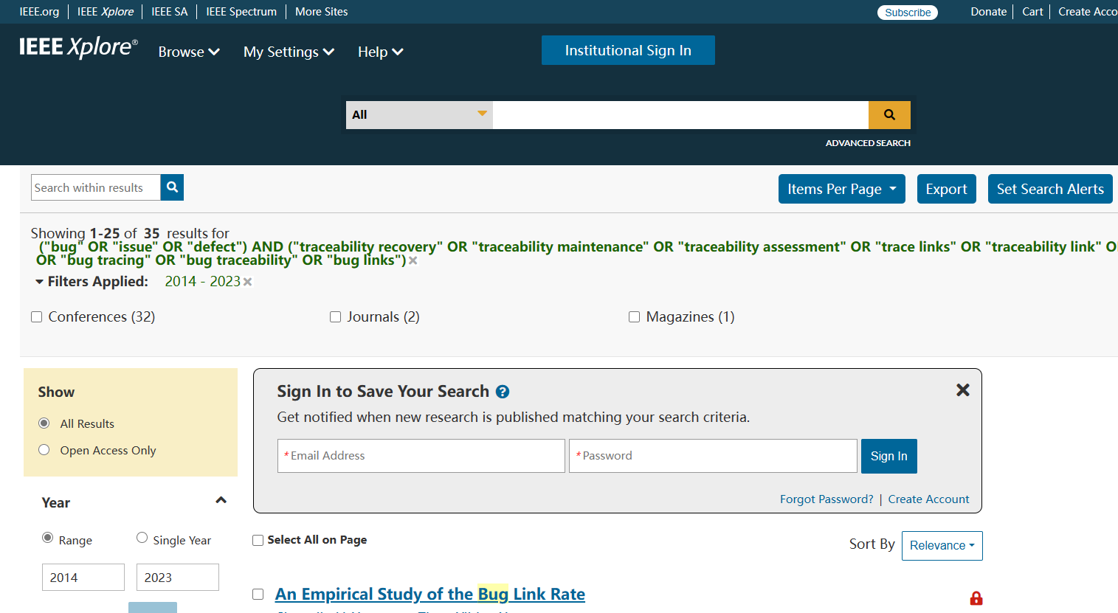

1. Wiley

Advanced search:

("bug" OR "issue" OR "defect") AND ("traceability recovery" OR "traceability maintenance" OR "traceability assessment" OR "trace links" OR "traceability link" OR "bug trace" OR "bug tracing" OR "bug traceability" OR "bug links")

**Screenshot of search process in** Wiley:

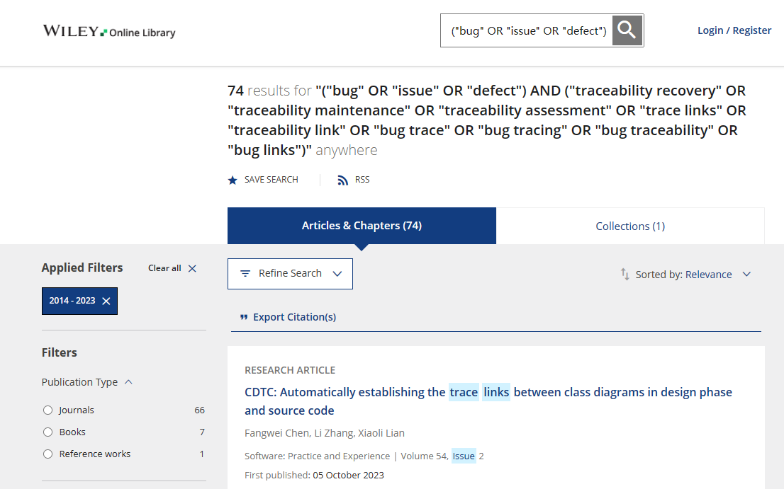

1. Springer

Advanced search:

("bug" OR "issue" OR "defect") AND ("traceability recovery" OR "traceability maintenance" OR "traceability assessment" OR "trace links" OR "traceability link" OR "bug trace" OR "bug tracing" OR "bug traceability" OR "bug links")

**Screenshot of search process in** Springer:

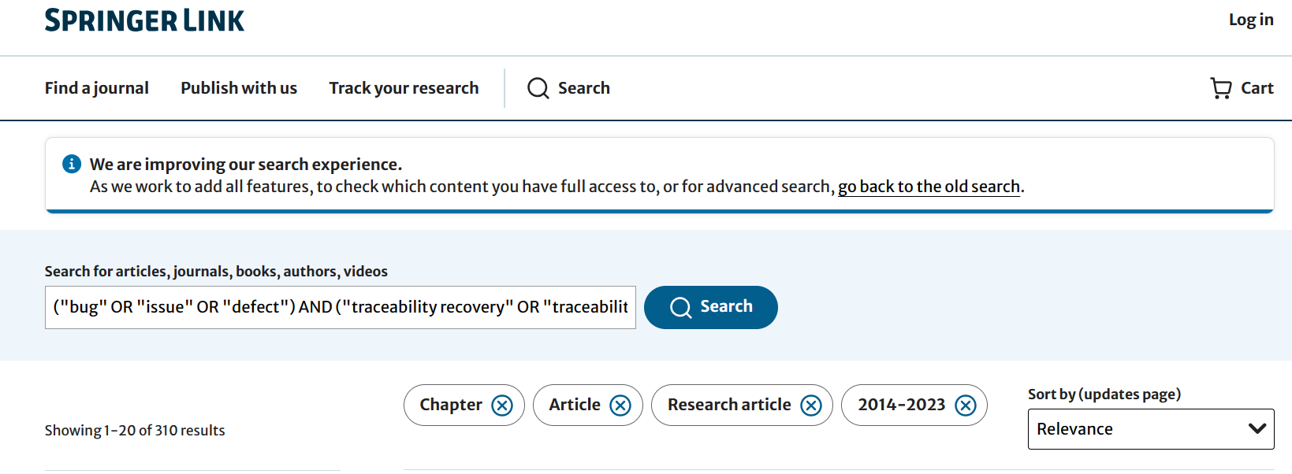

1. ACM

Advanced search:

("bug" OR "issue" OR "defect") AND ("traceability recovery" OR "traceability maintenance" OR "traceability assessment" OR "trace links" OR "traceability link" OR "bug trace" OR "bug tracing" OR "bug traceability" OR "bug links")

**Screenshot of search process in** ACM:

